Austin Rae McRae B.S., Sc.D., 10th Director 1915-20

McRae was born at McRae, Georgia on Oct 25, 1861. He died March 18, 1922 in Rolla, Missouri. Son of John Colin McRae and Elizabeth Jane (Clements) McRae, both from pioneer Georgia families.

He received his elementary and high school education in the schools in McRae, Georgia. He entered the University of Georgia at Athens, and graduated in 1881 with a degree of Bachelor of Science. He served as Captain of Co. B. Georgia Cadets and was also a member of Chi Phi fraternity.

He started working for the United States Signal Service in 1882 and was selected to make a special study of atmospheric electricity with reference to its possible utility as a means of forecasting approaching changes in weather conditions of the atmosphere. He entered Harvard in 1882 and received the degree of Doctor of Science in 1886.

From 1886-89, he returned to the U.S. Signal Service and studied electrical conditions of the atmosphere. In 1889, he traveled to Columbia, Missouri and organized a State Weather Service under the direction of the U.S. Signal Service and the Missouri State Board of Agriculture until August 1891. He also served as Assistant Professor of Physics at the University of Missouri at Columbia.

McRae was appointed Professor of Physics in June 1891. He worked in the field of physics and electrical engineering. He married Miss Minnie Wood of Rolla June 15, 1893. She was the daughter of Henry Wood and Sarah Edgar Wood. She was born on February 9, 1872. Her father operated a grocery store on Pine Street and was connected with a Rolla Bank and served as School of Mines Treasurer. Mrs. McRae attended the School of Mines and graduated from the Western Conservatory of Music in Rolla in 1888. She was an accomplished organist and pianist.

At the beginning of each school year the McRae’s would host the entire faculty group at a reception and also entertained each graduating class with an evening dinner. These events were held at the Director’s Residence on the school campus. They were parents of four children.

In 1894 McRae was elected Associate Professor of Physics at the University of Texas at Austin and held that position for two years. He then went to St. Louis where he worked as a Consulting Electrical Engineer for Hiram and Richard H. Phillips. He stayed there until 1899 when he accepted a position as Professor of Physics at the School of Mines.

Dr. McRae also held the distinction of being the first really capable faculty football coach. He coached the “Miner” team of 1893 – the first that wore distinctive “silver and gold” (orange and white) football uniforms. He supported all of the student sports on campus.

Professionally he became a Fellow of the American Association for the Advancement of Science, a member of the Society for the Promotion of Engineering Education, and the American Institute of Mining Engineers. He was also elected to Phi Beta Kappa and Tau Beta Pi. He also belonged to the American Academy of Political and Social Science. He served as a member of the Rolla City Council and engineer for the Rolla Electric Light and Power Plant. During World War I, he served as Chairman of the Phelps County Branch of the Red Cross, and National Defense Council. He also worked as a member of the Advisory Committee for Missouri for the U.S. Explosives Act. He suffered from a serious illness in1917, from which he never fully recovered. He resigned in 1920 and died in 1922. He was made Professor Emeritus of Physics of the School of Mines following his resignation in 1920.

He was an active free mason and participated in the student organization of Masons the “Square and Compass.” He also helped establish a local chapter of the De Molay and became their advisor. Following his death his remains lay in state in Parker Hall auditorium. Schools and businesses were closed during the hour of his funeral out of respect.

Dr. McRae began his directorship at odds with the Board of Curators over their refusal to support the Buford Act of 1915. They would not support curricula that would lead to the granting of further degrees as stated in the Buford Act. A notice of Mandamus Action against the Board of Curators was brought to the Supreme Court of Missouri The matter was taken to the Supreme Court where the Board was required to support the original language of the Buford Bill. One result of the Supreme Court’s decision and passage of the Buford Act was the re-installation of instruction of Military Tactics.

In the fall of 1916 many students immediately enrolled in the three new courses, Chemical, Electrical and Mechanical Engineering, to which the curators and UM President had objected.

Changes in Departments 1914-20
Department of Chemistry – Chemical Engineering – no marked changed from 1915-20 as many of the courses already being taught were sufficient for the degree in Chemical Engineering.
Department of Physics and Electrical Engineering – called the Dept of Physics until the end of the 1915-16 year. This department had also been teaching many courses equivalent for a degree in Electrical Engineering prior to the Buford Bill. The basic physics courses taught were theoretical work and formed the core of the Electrical Engineering work. Many courses formed the Department of Mechanical Engineering after the 1915-16 year. In 1919-20 the theoretical courses in Mechanical Engineering were transferred to the newly named Mechanical Engineering Dept – formerly referred to as the Department of Shop work and Drawing.
Department of Mechanical Engineering – The school was also giving the equivalent of a degree course in this field, and awarding the degree of Civil or Mining Engineer for that work. The Mechanical Engineering Degree had actually been set up in 1889; and prior to that, under the Bachelor of Philosophy or under the degrees of Civil or Mining Engineer. The Department of Drawing remained in this department also until the 1919-20 year, when it became once again, as under the Williams’ administration, a separate and distinct Department of Drawing. Shop work had been under different departments, first in the “Old Main” or “Rolla” building before 1902.
Department of Mathematics – Mechanics had been taught in this department until 1916-17 when the Department of Mechanics was established. It remained a separate department until 1941.
Department of Civil Engineering – Cement Testing Laboratory was installed in the basement of Parker Hall, beneath the auditorium wing. This was part of the Applied Mechanics Laboratory, which included such equipment as a Vicat needles, autoclave, drying oven, moist closet, and tension testing apparatus. The lecture and drafting rooms, departmental library and offices of the department were still on the third floor of Norwood Hall. The department also operated its compressed air and hydraulic laboratories in a section of the Power Plant Building, where it also housed its surveying equipment lockers.
Department of Mining Engineering - The department had its quarters in Norwood Hall, first floor, southwest corner of the room. It maintained Mine-Rescue and First Aid Laboratories, and a rock drilling laboratory, where it used huge blocks of red granite from Southeast Missouri, each block measuring 4 x 4 x 5 feet. Here it also had two displacement tanks 5 feet in diameter and 15 feet high used for measurement of air, and also a “Sirocco” 36 inch mine fan. Director Young had opened an experimental min on the School’s campus. During the McRae administration a number of vertical shafts were excavated on the northwest corner of the (1941) second athletic field (corner of State Street North and 17th St.); but during the 1913-14 year, under the Garrett administration, the present Experimental Mine Tract, adjacent to the Frisco railway tracks about one half mile west of the deep “Coleman” rock cut west of Rolla, was opened for experimental mine purposes. This tract is known as “Lot 112, Railroad Addition to Rolla, Missouri”, and was purchased on Jan 27, 1914 from the Long family of Rolla. From 1914 to 1920 rough buildings containing a boiler, air compressor, blacksmith shop, and rooms for tools were erected. The beginnings of the underground tunnel and workings were excavated by the students who, in their experimental work, actually engaged in drilling, blasting, timbering, and other realistic mining operations.
Department of Metallurgy and Ore Dressing – This department was located in the Metallurgy Building.
Department of English and Modern Foreign Languages – A strong program of English Literature, Engineering Writing, Debate, and in scientific French, German and Spanish were developed.
Department of Geology and Mineralogy – no major changes
Department of Physical Training – After 1915, this department was housed in the Jackling Gymnasium.
Department of Military Science and Tactics – This department was the re-establishment of military instruction 1917-18 school year. Professor Muilenburg, of the Geology Dept was appointed Colonel of school’s military department and Professor Armsby as Major. Both professors had been in the cadet corps at previous schools. Each physically fit male had to take military training and buy his uniform which consisted of a hat, blouse, breeches, leggings, and tan shoes (outfit minus the shoes cost $10.) From fall 1918 department was an Engineer Unit, Senior Division of ROTC (established Jan 1919). Major Herbert Joseph Wild, of the Engineer Corps, US Army, was attached to the School the 1918-19 year as its first official Professor of Military Science and Tactics.

Growth of School
- See chart below

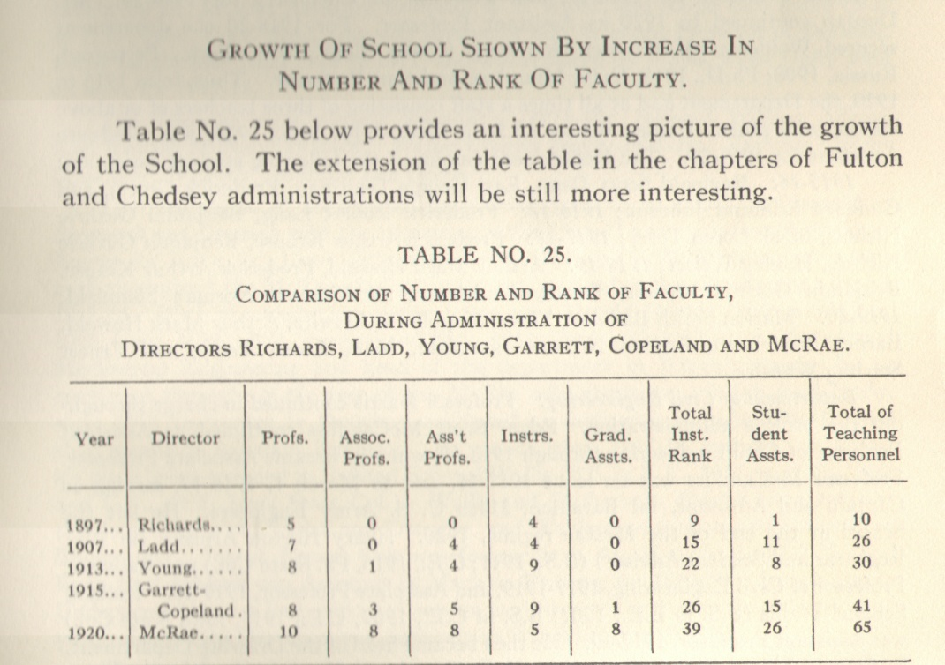

Faculty Turnover 1915-1920

Dept of Chemical Eng. –Victor Hugo Gottschalk was professor of chemistry and head of department from 1915 until 1916 when he went on leave to get his doctoral degree at Chicago University. While he was gone there were 3 teachers John Ingram, Lester Hammond, and Harry Ambler. Dr, Gottschalk came back in 1917 and brought William Turner and Howard Dunlap who became Assistant Professors of Chemistry. Dr. Gottschalk left the school at the end of 1917-18 and Dr. Turner became head of the department with the rank of Associate Profess for 1918-19 and Professor of Chemistry for 1919-20. Mr. Dunlap was Assistant Professor until 1920. Woldemar Markovitch Sternberg came to work 1918-20 as Assistant Professor. Hanley Weiser was graduate instructor.
Dept of Civil Eng. – Prof Harris continued to be in charge during McRae administration. Edgar S. McCandliss – Assistant Professor of Civil Engineering who left in 1920. Henry Armsby – Assistant Professor of Civil Engineering, 1917-19 and Associate Professor 1919-20. Roland S. Wallis – Assistant Professor 1917-19 -

